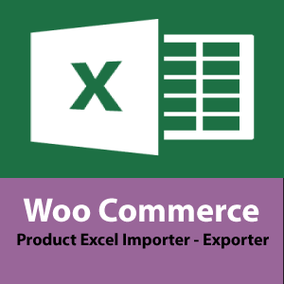
Get @ Wordpress https://el.wordpress.org/plugins/woo-product-excel-importer/
Visit Plugin’s Page: https://webdeveloping.gr/projects/woo-product-excel-importer/

Contents
1) PRODUCT SUPPORTED FIELDS 3
2) IMPORT PRODUCTS 3
HOW TO 3
3) EXPORT PRODUCTS 4
Search Feature 4
Columns to Show 4
HOW TO 4

PRODUCT SUPPORTED FIELDS

The fields supported in Import, Export Features are:
- Title
- Description
- Excerpt
- Product Category (multiple comma separated, terms created on import or from existing terms)
- Product Tags (multiple comma separated, terms created on import or from existing terms)
- Weight
- SKU
- Regular Price
- Sale Price
- Stock
- Author ID (import only)
- Url – Slug (import only)
- Virtual

IMPORT PRODUCTS
Insert in your excel file one product per row. Supported fields are defined above.

HOW TO
- Navigate to Woo Product Importer (Import-Update Products Tab).
- Insert in your excel file your products information.
- Choose the excel in the import screen.
- Map the fields.
- Click Upload and Done!

Example excel:
TITLE | AUTHOR ID | URL SLUG | STATUS | DESCRIPTION | EXCERPT | SKU | WEIGHT | REGULAR PRICE | SALE PRICE | STOCK
title 1 | 1 | this-is-my-title-1 | publish | description for title 1 | excerpt 1 | 1 | 1 | 10 | 9 | 5

TO IMPORT AND UPDATE SIMPLE AND VARIABLE PRODUCTS GET THE PRO VERSION

EXPORT PRODUCTS

With the export feature you can export products as your reference for updating them back in the import screen. export Simple and Variable Products,
- Export those you need base on Search Criteria,
- choose What Columns to Export in your excel file

Search Feature
You can use certain criteria to export the products you need. Criteria is based on Keyword.

Columns to Show
You can shoose what columns to extract such as Fields (Title, Description, Prices, Stock Dimensions etc) , Product Taxonomies (category, tags)
HOW TO
- Navigate to Woo Product Importer Export Products.
- Use search filters to export what you need
- Select Columns to show
- Press Search

GET MORE FEATURES WITH PRO VERSION
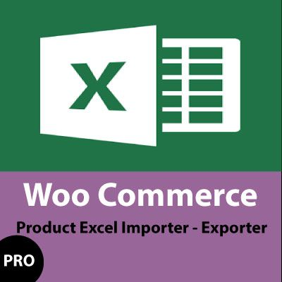 | - Import / Update Simple + Variable Products with unlimited Attributes + more fields  - Export Simple - Variable Products - get more Product fields  - Delete Products with Excel  - Import / Delete Categories with Excel  - Upload a Product Image from Url as Featured Image  - Import Images in Product Gallery  - Import Custom Taxonomies along with Products  - Define Downloadable Product, Download url,Download Name, Limit, Expiry  - Extra Fields Support: Purchase Note, Featured image, Product Gallery, Downloadable, Upsell, Crossell etc.
Get it here

